**OPENER EXAM YEAR 2021 TERM 2**

**PHYSICS FORM THREE PRACTICAL PAPER 3**

**TIME: 2HRS; 15MINS**

1. You are provided with the following;

* a rectangular glass block
* 4 optical pins
* a soft board
* a plain paper

Proceed as follows:

(a) Place the glass block on the plain paper with one of the largest face upper most. Trace round the glass block using a pencil as shown below.

A

P1

P2

i

B

L

b

r

eye

D

P4

P3

c

(b) Remove the glass block and construct a normal at B. Construct an incident ray AB of angle of incidence, i = 200.

(c) Replace the glass block and trace the ray ABCD using the optical pins.

(d) Remove the glass block and draw the path of the ray ABCD using a pencil. Measure length L and record it in the table below.

|  |  |  |  |  |
| --- | --- | --- | --- | --- |
| Angle *i0* | L (cm) | L2 (cm2) |  | Sin2*i* |
| 20 |  |  |  | 0.1170 |
| 30 |  |  |  | 0.2500 |
| 40 |  |  |  | 0.4132 |
| 50 |  |  |  | 0.5868 |
| 60 |  |  |  | 0.7500 |
| 70 |  |  |  | 0.8830 |

**(6 marks)**

(e) Repeat the procedure above for the angles of incidence given.

(f) Calculate the value of L2 and ; Record in the table.

(g) Plot a graph of $\frac{1}{L^{2}}$ (y-axis) against Sin2*i* . **(5 marks)**

(h) Calculate the gradient, S. **(3 marks)**

Given that the equation of that graph is: : $\frac{1}{L^{2}}=- \frac{1}{n^{2}b^{2}} ∙ {Sin}^{2}i+ \frac{1}{b^{2}}$

(i) Determine the $\frac{1}{L^{2}}$– intercept C and the Sin2*i –* intercept B.

C = _______________________________________ **(1 mark)**

B = _______________________________________ **(1 mark)**

(j) Calculate the value of Q given by; **(2 marks)**

$Q= -\left(\frac{C}{S}\right) ÷B$

(k) Hand in your constructions on the plain paper together with the answer script. **(2 marks)**

*2 .You are provided with the following;*

* *A pendulum bob*
* *Two pieces of wood*
* *A retort stand*
* *A boss*
* *A clamp*
* *A ctop watch*
* *A metre rule/or half metre rule*
* *A piece of thread*

**Proceed as follows;**

a) Suspend a pendulum bob on a retort stand as shown below.

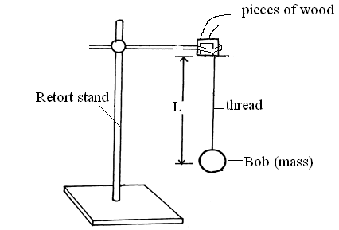

b) Displace the bob for a small angle. As it is oscillating time ten oscillations for every length of the string shown in the table below (9marks)

|  |  |  |  |  |  |  |
| --- | --- | --- | --- | --- | --- | --- |
| ***Length, l(m)*** | 0.4 | 0.6 | 0.8 | 1.0 | 1.2 | 1.4 |
| **Time ,t, for 10 oscillations(s)** |  |  |  |  |  |  |
| **Periodic time, T(s)** |  |  |  |  |  |  |
| **F=(Hz)** |  |  |  |  |  |  |
| **F2(Hz2)** |  |  |  |  |  |  |
| **(m-1)** |  |  |  |  |  |  |

C) Plot a graph of F2 against 1/L. (5 marks)

d) Determine the slope,**S**, of the graph. (3 marks)

………………………………………………………………………………………………………………………………………………..........................................................................................................................................................................................................................................................................................................................................................................................................................................................................................................................................................................................................................................................................................................................................................................................................................................................

e) Given that the relationship between **F** and **L** is given by*,* ***F2 =***  ,use the graph to determine the value of **g** giving its units . ( 3marks)

…………………………………………………………………………………………………

………………………………………………………………………………………………………

…………………………………………………………………………………………………